Artificial intelligence model for continuous, in-home, posture and health monitoring including user feedback and predictions of clinical assessment.

David Faith Odesola

Table of Contents

List of Figures 3

Introduction 4

Objectives 4

Research Methodology 5

Protocol 5

Formulation of Research Questions 6

Search Strategy 6

Study Screening and Selection 6

Data Extraction 6

Results 7

Sitting Posture Monitoring Systems 7

History of Smart Sensing chairs 7

Sensor systems 8

Machine Learning Classification Method 12

Machine Learning Performance Validation 12

Different Sitting Postures 12

User Feedback System 12

(Internet of Things) IoT Integration with smart sensing chairs 13

Challenges and Limitations 14

Research Gaps 14

The use and impact of Mobile apps in the healthcare sector 14

Discussion 14

Commercialization 14

Future Directives and Trends 14

Systematic Mapping 15

Conclusion 15

References 16

Appendixes 19

# List of Figures

Figure 1 - Research Methodology Flowchart 5

Figure 2 – Timeline Map of Similar Literatures 7

Figure 3 - A Map of Similar Studies on Smart Sensing Chairs 8

Figure 4- A Force Sensing Resistor 9

Figure 5 - Textile Pressure Sensor composition [16] 10

Figure 6 - Flex Sensor 10

Figure 7 - Feedback System Percentage 12

## Introduction

According to Gill et al. [1] in 2020 alone, musculoskeletal disorders (MSDs) had been ranked 2nd as the leading non-fatal disability which has been affecting more than a billion people worldwide. In Finland, MSD had taken the spotlight as being the leading cause of temporal disability within the nation. As a result, this has led to a substantial amount of resources being allocated towards the health services [2]. It might be misconceived that only the elderly are the only ones that suffer from this condition. However, a report by the European Agency for Safety and Health at Work (EU-OSHA) in 2021 [3] had concluded that quite a number of individuals across different age groups are currently suffering from MSD. It was reported that MSDs can often originate during the childhood stage mainly due to adoption of abnormal postures and low physical activities, which subsequently lead to long-term chronic pain, discomfort, and physical limitations. Traditional examination and treatment procedures most often consist of regular clinical visits and are currently viewed as being inconvenient and costly. According to Bevan in 2015 [4], MSDs have said to have cost the European Union (EU) over 2% of its gross domestic product (GDP), which is estimated to be over €240bn each year. There is no doubt that this is a steadily growing concern that needs to be properly addressed. The mortality rates caused by MSDs are said to be among the lowest seen. This phenomenon has most likely led to shift of attention and resources towards other health priorities [5].

Nowadays, most of the in-office work requires staff members to be in a seated position for an extended period, which is said to have adverse effects to one’s health. According to [6] and [7], prolong sitting has been one of the leading causes of MSDs that has been affecting office workers. It is therefore recommended that the users should go for small walk breaks after every few hours. The integration of smart sensing chairs into home or office work environments, actively monitoring and providing feedback on user’s health and activity levels would be deemed quite useful.

Furthermore, with the rapid advancement in data sensor technology and Artificial Intelligence in this present age, there should be new and commercialized solutions out there in the market for continuous posture and health monitoring. There is no doubt that these types of systems have the potential of contributing towards the idea of personalized healthcare and improving the quality of life, especially for individuals that are suffering from MSDs.

With that in mind, various research studies have investigated the development of posture monitoring systems, with an aim to assist the end user in maintaining the right sitting posture at every given time. These types of systems are named “smart sensing chairs”. This concept goes all the way back to the first research study that was done by Tan et al back in 2001 [8], who fitted a chair with a pressure distribution sensor in order to classify a user’s sitting postures which was just first of many.

## Objectives

Furthermore, with a lot of research papers being published in this field, this study aims to evaluate related published papers and identify research gaps that can pave the way for further investigation into this study. By exploring existing studies, it is possible to gain a better understanding of the current state on the implementation of a smart sensing chair for posture classification and health monitoring. Hence, a systematic review method was formulated to efficiently analyze existing studies of smart sensing systems.

## Research Methodology

This paper is aimed at conducting a systematic review of similar research studies done on smart sensing chair technology. The research method that would be used is the study would be based on the Cochrane review methodology. Overall, there are **9** steps involved with this systematic review process which is the following:

1. Formulation of Research Questions
2. Protocol
3. Search Strategy
4. Study Screening and Selection
5. Data Extraction
6. Bias Risk Assessment
7. Data Synthesis
8. Discussion
9. Conclusion and Recommendations

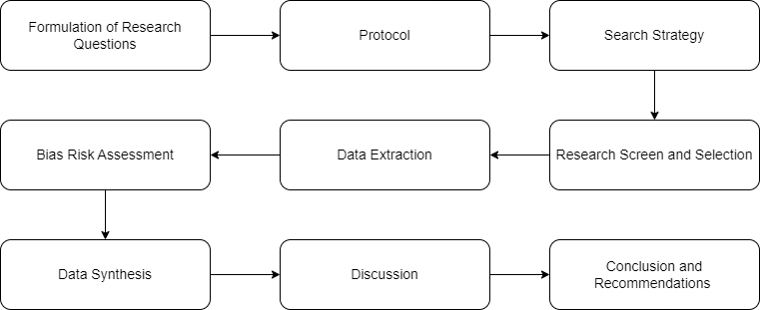

Figure - Research Methodology Flowchart

### Protocol

<Insert Protocol Content>

### Formulation of Research Questions

The following are the relevant research questions that must be answered within this systematic literature review.

1. What are the sensors that are mostly being used among similar studies?
2. What methods are being used to classify different sitting postures?
3. What are the limitations and research gaps seen with existing studies?
4. How useful was the implemented user feedback mechanism?

### Search Strategy

Articles that were examined came from various online publication sources such as [**Semantic Scholar**](https://www.semanticscholar.org/), [**Google Scholar**](https://scholar.google.com/), [**IEEE Explore**](https://ieeexplore.ieee.org/Xplore/home.jsp), and[**MDPI journals**](https://www.mdpi.com/about/journals)to name majority of them. To aid in the search for the relevant articles though different database systems, a list of important keywords was clearly defined to ensure that the most relevant papers came in the search results. Additionally, some of these “keywords” were combined to achieve better search results. Below are some of the search terms that was used. Additionally, filters were applied to find relevant studies that were published in the past 20 years.

1. Smart Sensing Chair
2. Sitting Posture Recognition
3. Posture Classification
4. Sitting Posture Classification using AI/Machine Learning
5. Sitting Posture Monitoring

### Study Screening and Selection

The initial screening of research papers involves reviewing both their title and abstract content to identify its relevancy to the research topic. As previously stated, a search filter was applied to narrow down the research studies that were published in the past 20 years. Overall, a total of **33** papers across various research databases were identified for further consideration. These papers were then imported into Zotero for reference management.

### Data Extraction

Once the relevant research papers were found and collected, the data extraction phase was followed. This phase is primarily focused on extracting the relevant information which relates back to the research questions that need to be answered in the systematic literature review. Listed below are the following information that was captured while going through each paper:

* Authors
* Published Year
* Sensors Used
* Sensor Placement
* Number of Postures Classified
* Recognized Postures
* Classification Method
* Classification Accuracy
* Limitations
* User Feedback System
* Is Realtime
* Method Used

## Discussion

### Sitting Posture Monitoring Systems

As previously stated, the development of a sitting posture monitoring system is not an entirely new concept, rather it is an area that has been explored by multiple researchers in the past until this present day. This section would be going over different research projects that developed their variation of smart sensing chairs. To efficiently conduct this literature review, a total of 33 relevant research literatures were carefully selected and examined as seen in Table 1. have been published focusing on the of the use of unobtrusive means for the classification of different sitting positions. Systematically examining these papers would surely some shed light on the most common machine learning algorithms and sensors being used to be able to classify various sitting postures.

### History of Smart Sensing chairs

As previously stated, [8] was the first research seen to pioneer the idea of a smart sensing chair that is capable of detecting one’s posture by using pressure distribution sensors integrated into the chair. Over the past few years, various research studies have implemented different variations of these smart sensing chair concepts ranging from different sensors to various classification methods to posture detection as shown in Figure 1. Furthermore, a literature connection map (on similar studies) done on smart sensing chairs was constructed as shown in Figure 2 below. This figure gives a rough visualization of the amount of research being done in landscape of smart sensing chair technology.

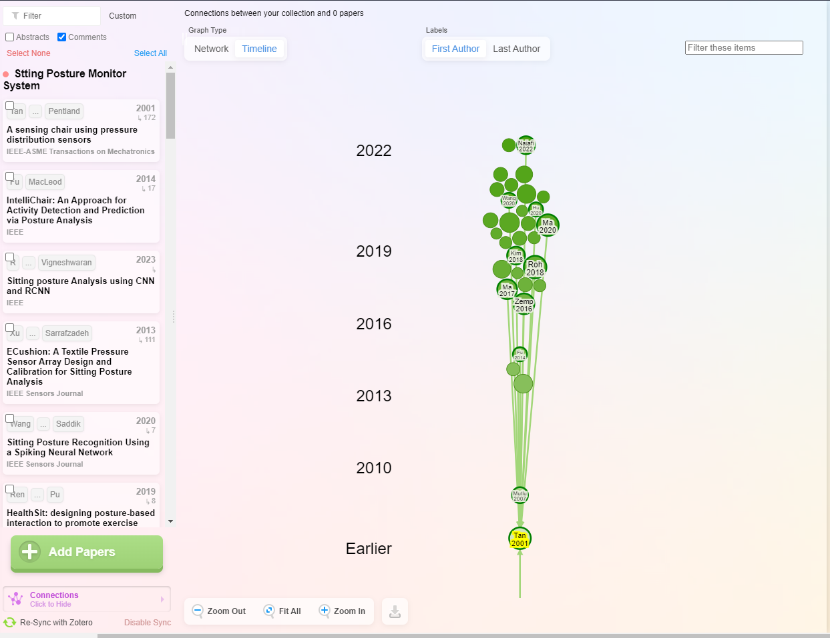

Figure – Timeline Map of Similar Literatures

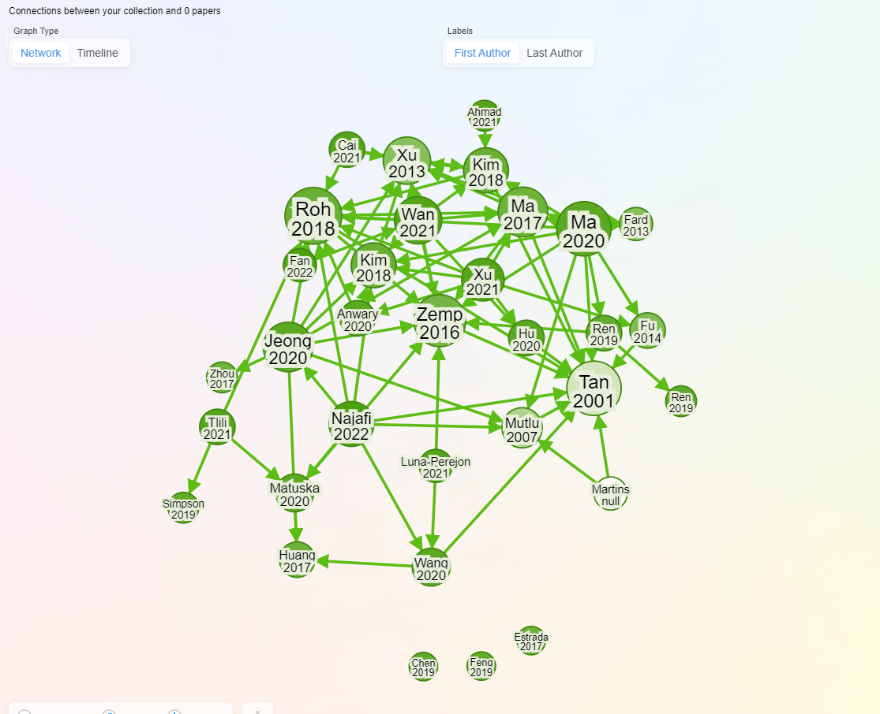

Figure - A Map of Similar Studies on Smart Sensing Chairs

### Sensor systems

As anticipated, various scholarly papers use different types of sensor devices to detect different sitting postures. In summary, they can be divided into 4 overarching categories:

* Smart Sensing Chairs using Pressure Sensors
* Smart Sensing Chairs using Flex Sensors
* Smart Sensor Chairs using Mixed Sensor Systems
* Smart Sensing Chairs using Image Processing

#### Sensing Chair using Pressure Sensors

##### Force Sensing/Sensitive Sensor (FSR)

Force Sensing Resistors are also known as force sensors which are commonly used to measure the forces applied to its surface area. These sensors work by varying their output resistance based on the pressure being applied to it. Typically, the overall resistance decreases as more pressure is applied [9]. To be able to get the reading from this sensor, it normally connected directly to a microcontroller such as an Arduino or like get its reading. Figure 1 shows an example of how a FSR sensor commonly looks like.

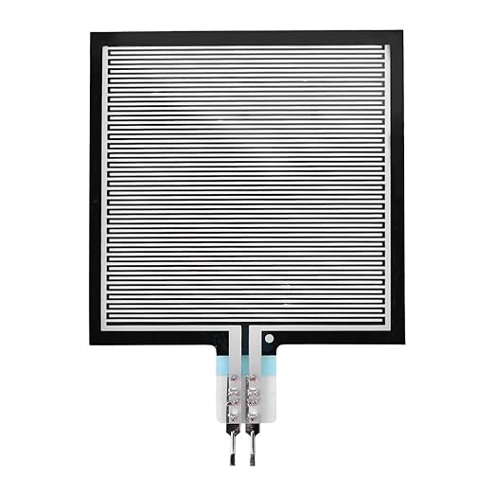

Figure - A Force Sensing Resistor

Focusing on studies that integrated FSRs in to their studies, Mutlu et al. in 2007 [10] integrated 19 different FSRs into the seating cushion and used the SimpleLogistic ML algorithm to achieve 78% accuracy in classifying 10 different postures. Tsai et al. [11] used 13 pressure sensors classify 10 sitting postures and was able to achieve an accuracy of 99.10% using the SVM ML algorithm. Aminosharieh Najafi et al. [12] applied 8 sensors (4 on the seating cushion and 4 on the back rest) and used EMN algorithm to classify 8 sitting posture and achieved an accuracy of 91.68%. In addition to this, there was a Desktop Graphical User Interface (GUI) application which displayed the senor reading in real-time. [13] added 6 sensors which was placed on the seating cushion and resulted in an 81.5% classification accuracy using SOM (ISOM-SPR) ML algorithm.

##### Load Cells

Load cells are another variation of force sensor which is commonly used to measure monitor sitting postures. Under the hood, it works by converting the mechanical force being applied to it into digital signals which can be read by microcontrollers. Roh et al in 2018 [14] developed a smart chair by integrating 4 load cell sensors within the chair sitting cushion to classify 6 sitting postures. An accuracy of 97.94% was achieved using a SVM (RBF kernel) ML model. Similarly, Pereira and Plácido Da Silva in 2023 [15] distributed 3 load cells across the seat’s cushion in order to classify 8 sitting postures; overall they were able to a classification accuracy of 98.50%.

Figure - Load Cells

##### Textile Pressure Sensor

A textile-based pressure sensor is normally composed of a soft fabric material. This sensor consists of a conductive thread pattern placed over a dielectric material that serves as a substrate between the threads. Figure 4 shows an example of how each layer within the textile pressure sensor is structured.

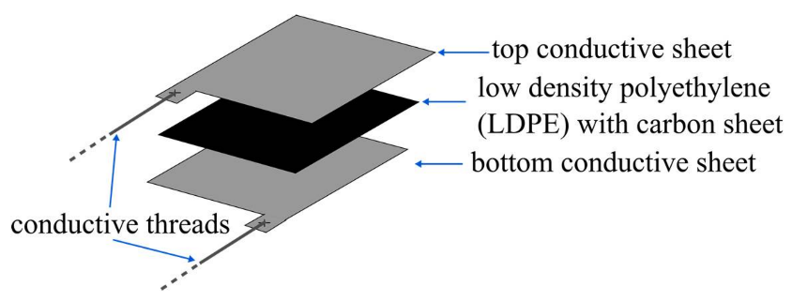

Figure - Textile Pressure Sensor composition [16]

A few research studies were found to have used textile sensors to classify sitting postures. One of which was Kim et al [17], who developed a washable textile pressure sensor and incorporated it into their chair system to classify 7 sitting posture using a decision algorithm. Another study proposed a “eCushion” device which is made up of a textile pressure array sensor that is capable of detect 7 different sitting postures at 85.9% accuracy [18]. Additionally, Martínez-Estrada et al [19] also developed something similar by using 10 presence textile capacitive sensor (embroidered) sensors.

#### Sensing Chair using Flex Sensors

Flex sensors are another variation of sensors that is being used by various studies to classify different sitting postures. A flex sensor, also known as a bend sensor works by measuring the degree of displacement resulting from the bending action being applied to the sensor [20].

It was seen that the primary use of flex sensors in the classification of sitting postures is not a widely popular approach among various studies. Overall, there were only 2 studies identified that utilized this method for sitting posture detection. The first was by Hu et al [21] who developed a smart sensing chair using 6 flex sensors and a 2-layer Artificial neural network (ANN) for detecting 7 sitting postures and achieved an accuracy of 97.43%. The second was by [22] which also developed a similar system without the use of an ML model which aimed at detecting 7 different sitting postures.

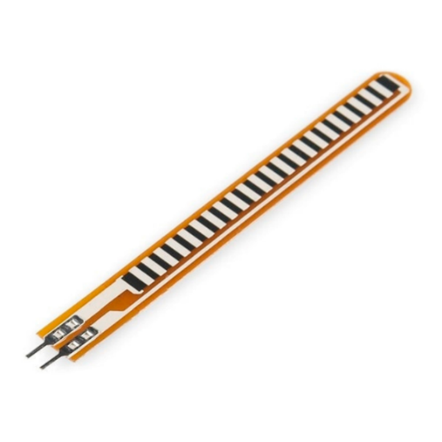

Figure - Flex Sensor

#### Sensing Chair using Mixed Sensors

While most studies utilize a singular type of sensor for posture detection, there are a selected few study that involved more than one type of sensor into their proposed smart chair system. With this method, the different sensors would theoretically work hand in hand to achieve the best classification outcome.

Jeong and Park [23] utilized 6 pressure sensors (placed on the seating cushion) along with 6 Infrared Reflective Distance Sensors (placed on the back rest). By using the K-Nearest Network (KNN), they were able to classify 11 different sitting postures while achieving an accuracy of 92%. This study also highlighted one of the main limitations seen with other smart sensing systems. It was stated that the main limitation of entirely relying on pressure sensors is that the angle of spinal trunk rotation can’t be detected, which is an important aspect of a sitting posture. Similarly, (Cho et al, 2019) [24], used 16 pressure sensors place on the sitting cushion along with 2 ultrasonic sensors placed at the neck support region. With this configuration, they were able to achieve a 96% accuracy using LBCNet to classify 15 sitting postures. Ma et al in 2020 [25] developed a smart seating cushion which employed the use 6 FSR sensors for detecting different sitting postures and an Inertial measurement unit (IMU) sensor to monitor user activity.

#### Smart Sensing Chairs using Image Processing

There were some research papers that have investigated the application of image processing in the detection of improper sitting postures. This approach mostly involves the utilization of a digital camera actively positioned directly on the subjects. Furthermore, by employing the use of image processing techniques and algorithms, one can analyze each video frame to determine the sitting posture.

Mallare et al. in 2017 [26] developed a system utilizing 2 cameras strategically positioned at (front and side) angles in the detection of bad sitting postures. Overall, they were only able to achieve an accuracy of 61.3% using the SVM algorithm. Chen in 2019 [27] further improved on this by using a Astra3D Sensor which is a 3D depth camera. By using the OpenPose library along with CNN for the posture classification, an accuracy of 90% was achieved.

### Machine Learning Classification Method

As expected, different machine learning algorithms are being used to classify different sitting postures. Two of the most used ML model among research studies was the CNN (Convolutional Neural Networks) [17,24,27–29] and ANN (Artificial Neural Networks) [13,30–33]. Other algorithms being used were KNN (K-Nearest Neighbors) [15,31], Decision Tree [25,34], SVM (Support Vector Machine) [11,14], RF (Random Forest) [35,36], SNN (Spiking Neural Network) [37], SLR (Simple Logistic Regression) [10], Self-Organizing Map [38], and Dynamic time Wrapping [18]. On the other hand, there were 7 studies that didn’t employ the use ML models in the classification of sitting postures [17,19,33,39–41]. Instead, most of these studies resulted in the implementation of straightforward threshold-based system. Using this approach, if the sensor data surpassed a specified threshold, a given posture is identified.

### Machine Learning Performance Validation

To perform concrete validation on an ML model’s performance and accuracy, most studies result in various methods such as the use of a confusion matrix and comparison between other ML models. A

### Different Sitting Postures

Taking an in-depth look at Table 1 it was seen that across all the gathered research papers, there are varying number of postures being classified. Upon further analysis, it was quite evident to see that the more sitting postures that are being classified, the less accuracy its classification accuracy would be. Hence, that is one of the main reasons why most studies on average limit the number of postures to 5-7 positions, which are leaning left, leaning right, leaning backward, upright sitting, and leaning forwards [42]. The study that had the least number of postures classified was by Feng et al. [35] who used RFID tag to classify 3 sitting postures (a. Sitting straight, b. Leaning Forward, c. Leaning Backward). On the other hand, Wang et al. [37] looked at detecting up to 15 different postures which was the highest seen among other studies.

### User Feedback System

The integration of a feedback system into a smart sensing chair is an integral component of enhancing the user experience. From the end user’s perspective, individuals should be able to receive real-time alerts whenever an improper sitting posture is being detected. It was seen that most studies focus on the classification aspects and leave out the implementation of a feedback platform. As shown in Figure 8 below, so far only 33% (11) of all the studies incorporated a kind of feedback platform that would encourage the user to maintain a correct posture. The implementation of mobile application was seen as the most used platform of alerting a user whenever an improper sitting posture is being detected. [24,31,38–40]. Another common method was the use of a Desktop application which was done by some studies [11,27,37,43]. Alternatively, instead of implementing an interactive platform such as a mobile or a desktop app, [32] proposed on the use of an haptic motor system integrated into the seating which would vibrate whenever an incorrect sitting posture is being detected. To even make the system as unintrusive as possible, [44] looked at using a RGB bulb capable of changing colors whenever an incorrect posture is being detected.

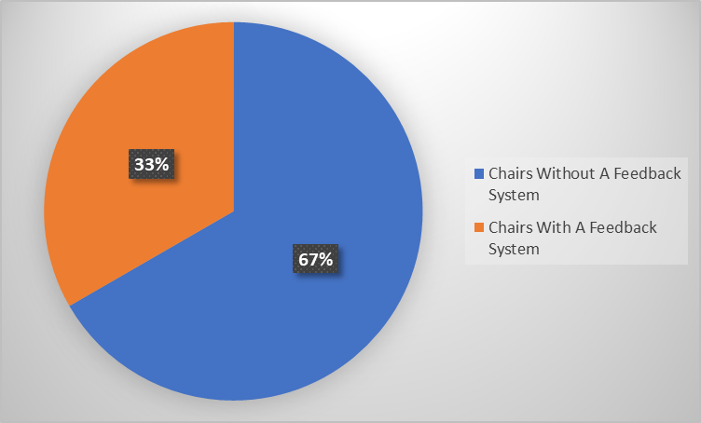

Figure - Feedback System Percentage

### (Internet of Things) IoT Integration with smart sensing chairs

Over recent years, IoT has gained in popularity and has become a game changer within certain industries. It was projected that by year 2030, there would be over 50 billion devices interconnected through IoT [45]. Ma et al. [25] highlighted the effectiveness of integrating IoT-based systems into healthcare sensors systems due to its major advantage of being able to seamlessly monitor user’s health data in real-time. The use of IoT systems for remote health monitoring is believed to not only reduce medical costs but could also aid in the early detection of chronic illnesses. Subsequently, this could potentially accelerate the treatment and improve overall life expectancy of an individual.

Now focusing on papers on smart sensing chairs that utilized IoT-based technology, Matuska et al. [39] used an Arduino-based microcontroller which communicated using the MQTT telemetry protocol in order detect 9 different sitting postures. The sensor data was sent in real-time data to a mobile application that alerted a user if an incorrect posture is being detected by signify ‘green”, “orange”, and “red” for standard sitting, bad sitting, and heavy load on backbone respectively. Similarly [40] developed a smart sensing chair which used the Blynk 2.0 platform to stream the sensor data to the web. Other studies such as [13] and [43] similarly used IoT for bad postures detection as well as providing valuable feedback to the end-user.

### Research Gaps and Limitations

Across all the research studies, it is apparent that there are different classification methods being used to classify different sitting postures. However, as previously discussed it was seen that a majority of studies primarily focus on the classification aspects of things and leave out the implementation of a feedback system to guide the user in maintaining a correct sitting posture. As discussed in the previous section, only 33% (11) of studies found developed an interface that would enforce correct sitting posture; five of which implemented the use of mobile application. Overall, the implementation of a mobile application looks to be a useful approach in notifying the end-users about maintaining proper sitting postures. However, it is quite important to acknowledge the research gap in this field of interest – specifically the lack of comprehensive evaluations in accessing user’s experience with these applications.

These few studies looked at the implementation of mobile application as a means of providing real-time feedback on one’s sitting postures. However, due to the lack of a comprehensive evaluation being conducted, a few questions are raised regarding the effectiveness, feasibility, and overall satisfaction from the user’s perspective when interacting with these apps. According to ___, it is beneficial to capture other users’ perspective on a mobile app to gain a deep understanding of its strengths and weaknesses.

To address this research gap, future studies should go beyond focusing on achieving high classification accuracy of different sitting postures and prioritize conduction user-centered evaluations on 5the implemented feedback system. Methods such as interviews, surveys, and usability testing could be employed to collect valuable feedback. With this done, it would be very easy to gauge and measure the effectiveness of the proposed feedback system.

### The use and impact of Mobile apps in the healthcare sector

The use of mobile phones in the healthcare sector has rapidly been gaining in popularity in recent times. Mobile Health (MHealth) apps are mobile applications that are mostly tailored towards assisting both medical professionals and patients in the aspects of health management. According to (Lohnar, 2016), the number of mHealth apps are expected to be on an upward trend.

According to various studies, there are a series of hurdles and issues that must be put into consideration during the implementation of a mHealth app.

## Conclusion

**RQ1: What are the sensors that are being used by similar studies?**

Across all the research studies, various sensors are being used as a means towards the detection of sitting postures. Force Sensitive Resistor (FSR) was seen as the most used sensors among research studies. Other sensors such as Load Cells, Flex Sensors, and computer vision systems were also explored by a handful number of research papers.

**RQ2: What methods are being used to classify different sitting postures?**

**In order to validate**

**RQ3: What are the limitations and research gaps seen with existing studies?**

**RQ4: How useful was the implemented user feedback mechanism?**

### Commercialization

### Future Directives and Trends

### Systematic Mapping

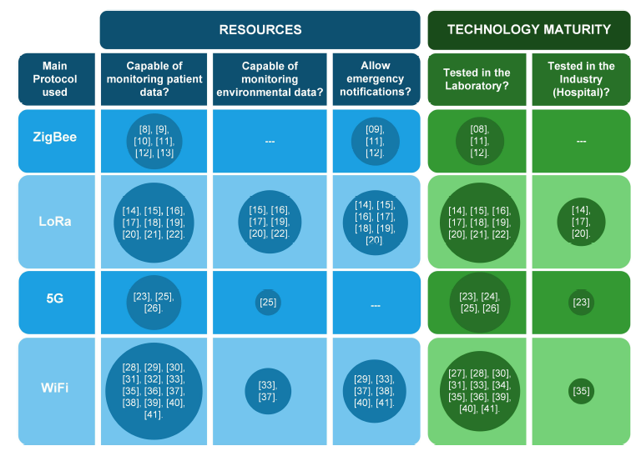

DO SOMETHING SIMILAR TO THIS (Reno et al)

## Conclusion

## References

1. Gill, T.K.; Mittinty, M.M.; March, L.M.; Steinmetz, J.D.; Culbreth, G.T.; Cross, M.; Kopec, J.A.; Woolf, A.D.; Haile, L.M.; Hagins, H.; et al. Global, Regional, and National Burden of Other Musculoskeletal Disorders, 1990–2020, and Projections to 2050: A Systematic Analysis of the Global Burden of Disease Study 2021. *The Lancet Rheumatology* **2023**, *5*, e670–e682, doi:10.1016/S2665-9913(23)00232-1.

2. Martimo, K.-P. *Musculoskeletal Disorders, Disability, and Work*; Finnish Institute of Occupational Health: Helsinki, Finland, 2010; ISBN 978-951-802-987-1.

3. European Agency for Safety and Health at Work. *Musculoskeletal Disorders among Children and Young People: Prevalence, Risk Factors and Preventive Measures : A Scoping Review.*; Publications Office: LU, 2021;

4. Bevan, S. Economic Impact of Musculoskeletal Disorders (MSDs) on Work in Europe. *Best Practice & Research Clinical Rheumatology* **2015**, *29*, 356–373, doi:10.1016/j.berh.2015.08.002.

5. Summers, K.; Jinnett, K.J.; Bevan, S. Musculoskeletal Disorders, Workforce Health and Productivity in the United States. *The Center for Workforce Health and Performance* **2015**.

6. Arora, S.N.; Khatri, S. Prevalence of Work-Related Musculoskeletal Disorder in Sitting Professionals. *Int J Community Med Public Health* **2022**, *9*, 892, doi:10.18203/2394-6040.ijcmph20220259.

7. Putsa, B.; Jalayondeja, W.; Mekhora, K.; Bhuanantanondh, P.; Jalayondeja, C. Factors Associated with Reduced Risk of Musculoskeletal Disorders among Office Workers: A Cross-Sectional Study 2017 to 2020. *BMC Public Health* **2022**, *22*, 1503, doi:10.1186/s12889-022-13940-0.

8. Tan, H.Z.; Slivovsky, L.A.; Pentland, A. A Sensing Chair Using Pressure Distribution Sensors. *IEEE/ASME Trans. Mechatron.* **2001**, *6*, 261–268, doi:10.1109/3516.951364.

9. Sadun, A.S.; Jalani, J.; Sukor, J.A. Force Sensing Resistor (FSR): A Brief Overview and the Low-Cost Sensor for Active Compliance Control.; Jiang, X., Chen, G., Capi, G., Ishll, C., Eds.; Tokyo, Japan, July 11 2016; p. 1001112.

10. Mutlu, B.; Krause, A.; Forlizzi, J.; Guestrin, C.; Hodgins, J. Robust, Low-Cost, Non-Intrusive Sensing and Recognition of Seated Postures. In Proceedings of the Proceedings of the 20th annual ACM symposium on User interface software and technology; ACM: Newport Rhode Island USA, October 7 2007; pp. 149–158.

11. Tsai, M.-C.; Chu, E.T.-H.; Lee, C.-R. An Automated Sitting Posture Recognition System Utilizing Pressure Sensors. *Sensors* **2023**, *23*, 5894, doi:10.3390/s23135894.

12. Aminosharieh Najafi, T.; Abramo, A.; Kyamakya, K.; Affanni, A. Development of a Smart Chair Sensors System and Classification of Sitting Postures with Deep Learning Algorithms. *Sensors* **2022**, *22*, 5585, doi:10.3390/s22155585.

13. Luna-Perejón, F.; Montes-Sánchez, J.M.; Durán-López, L.; Vazquez-Baeza, A.; Beasley-Bohórquez, I.; Sevillano-Ramos, J.L. IoT Device for Sitting Posture Classification Using Artificial Neural Networks. *Electronics* **2021**, *10*, 1825, doi:10.3390/electronics10151825.

14. Roh, J.; Park, H.; Lee, K.; Hyeong, J.; Kim, S.; Lee, B. Sitting Posture Monitoring System Based on a Low-Cost Load Cell Using Machine Learning. *Sensors* **2018**, *18*, 208, doi:10.3390/s18010208.

15. Pereira, L.; Plácido Da Silva, H. A Novel Smart Chair System for Posture Classification and Invisible ECG Monitoring. *Sensors* **2023**, *23*, 719, doi:10.3390/s23020719.

16. Pizarro, F.; Villavicencio, P.; Yunge, D.; Rodríguez, M.; Hermosilla, G.; Leiva, A. Easy-to-Build Textile Pressure Sensor. *Sensors* **2018**, *18*, 1190, doi:10.3390/s18041190.

17. Kim, M.; Kim, H.; Park, J.; Jee, K.-K.; Lim, J.A.; Park, M.-C. Real-Time Sitting Posture Correction System Based on Highly Durable and Washable Electronic Textile Pressure Sensors. *Sensors and Actuators A: Physical* **2018**, *269*, 394–400, doi:10.1016/j.sna.2017.11.054.

18. Xu, W.; Huang, M.-C.; Amini, N.; He, L.; Sarrafzadeh, M. eCushion: A Textile Pressure Sensor Array Design and Calibration for Sitting Posture Analysis. *IEEE Sensors J.* **2013**, *13*, 3926–3934, doi:10.1109/JSEN.2013.2259589.

19. Martínez-Estrada, M.; Vuohijoki, T.; Poberznik, A.; Shaikh, A.; Virkki, J.; Gil, I.; Fernández-García, R. A Smart Chair to Monitor Sitting Posture by Capacitive Textile Sensors. *Materials* **2023**, *16*, 4838, doi:10.3390/ma16134838.

20. Sreejan, A.; Narayan, Y.S. A Review on Applications of Flex Sensors. *International Journal of Emerging Technology and Advanced Engineering* **2017**, *7*, 97–100.

21. Hu, Q.; Tang, X.; Tang, W. A Smart Chair Sitting Posture Recognition System Using Flex Sensors and FPGA Implemented Artificial Neural Network. *IEEE Sensors J.* **2020**, *20*, 8007–8016, doi:10.1109/JSEN.2020.2980207.

22. AbuTerkia, I.; Hannoun, M.; Suwal, B.; Ahmed, M.S.; Sundaravdivel, P. FPGA-Based Smart Chair Recognition System Using Flex Sensors. In Proceedings of the 2022 IEEE 15th Dallas Circuit And System Conference (DCAS); IEEE: Dallas, TX, USA, June 17 2022; pp. 1–2.

23. Jeong, H.; Park, W. Developing and Evaluating a Mixed Sensor Smart Chair System for Real-Time Posture Classification: Combining Pressure and Distance Sensors. *IEEE J. Biomed. Health Inform.* **2021**, *25*, 1805–1813, doi:10.1109/JBHI.2020.3030096.

24. Cho, H.; Choi, H.-J.; Lee, C.-E.; Sir, C.-W. Sitting Posture Prediction and Correction System Using Arduino-Based Chair and Deep Learning Model. In Proceedings of the 2019 IEEE 12th Conference on Service-Oriented Computing and Applications (SOCA); IEEE: Kaohsiung, Taiwan, November 2019; pp. 98–102.

25. Ma, C.; Li, W.; Gravina, R.; Du, J.; Li, Q.; Fortino, G. Smart Cushion-Based Activity Recognition: Prompting Users to Maintain a Healthy Seated Posture. *IEEE Syst. Man Cybern. Mag.* **2020**, *6*, 6–14, doi:10.1109/MSMC.2019.2962226.

26. Mallare, J.C.T.; Pineda, D.F.G.; Trinidad, G.M.; Serafica, R.D.; Villanueva, J.B.K.; Dela Cruz, A.R.; Vicerra, R.R.P.; Serrano, K.K.D.; Roxas, E.A. Sitting Posture Assessment Using Computer Vision. In Proceedings of the 2017IEEE 9th International Conference on Humanoid, Nanotechnology, Information Technology, Communication and Control, Environment and Management (HNICEM); IEEE: Manila, Philippines, December 2017; pp. 1–5.

27. Chen, K. Sitting Posture Recognition Based on OpenPose. *IOP Conf. Ser.: Mater. Sci. Eng.* **2019**, *677*, 032057, doi:10.1088/1757-899X/677/3/032057.

28. Fan, Z.; Hu, X.; Chen, W.-M.; Zhang, D.-W.; Ma, X. A Deep Learning Based 2-Dimensional Hip Pressure Signals Analysis Method for Sitting Posture Recognition. *Biomedical Signal Processing and Control* **2022**, *73*, 103432, doi:10.1016/j.bspc.2021.103432.

29. R, N.; Sudhakar, T.; Bethanney Janney, J.; Krishnamoorthy, N.R.; Dhanalakshmi, K.; Vigneshwaran, S. Sitting Posture Analysis Using CNN and RCNN. In Proceedings of the 2023 International Conference on Bio Signals, Images, and Instrumentation (ICBSII); IEEE: Chennai, India, March 16 2023; pp. 1–5.

30. Huang, M.; Gibson, I.; Yang, R. Smart Chair for Monitoring of Sitting Behavior. *KEG* **2017**, *2*, 274, doi:10.18502/keg.v2i2.626.

31. Martins, L.; Lucena, R.; Belo, J.; Santos, M.; Quaresma, C.; Jesus, A.P.; Vieira, P. Intelligent Chair Sensor. In *Engineering Applications of Neural Networks*; Iliadis, L., Papadopoulos, H., Jayne, C., Eds.; Communications in Computer and Information Science; Springer Berlin Heidelberg: Berlin, Heidelberg, 2013; Vol. 383, pp. 182–191 ISBN 978-3-642-41012-3.

32. Ran, X.; Wang, C.; Xiao, Y.; Gao, X.; Zhu, Z.; Chen, B. A Portable Sitting Posture Monitoring System Based on a Pressure Sensor Array and Machine Learning. *Sensors and Actuators A: Physical* **2021**, *331*, 112900, doi:10.1016/j.sna.2021.112900.

33. Ren, X.; Yu, B.; Lu, Y.; Chen, Y.; Pu, P. HealthSit: Designing Posture-Based Interaction to Promote Exercise during Fitness Breaks. *International Journal of Human–Computer Interaction* **2019**, *35*, 870–885, doi:10.1080/10447318.2018.1506641.

34. Fu, T.; Macleod, A. IntelliChair: An Approach for Activity Detection and Prediction via Posture Analysis. In Proceedings of the 2014 International Conference on Intelligent Environments; IEEE: China, June 2014; pp. 211–213.

35. Feng, L.; Li, Z.; Liu, C. Are You Sitting Right?-Sitting Posture Recognition Using RF Signals. In Proceedings of the 2019 IEEE Pacific Rim Conference on Communications, Computers and Signal Processing (PACRIM); IEEE: Victoria, BC, Canada, August 2019; pp. 1–6.

36. Zemp, R.; Tanadini, M.; Plüss, S.; Schnüriger, K.; Singh, N.B.; Taylor, W.R.; Lorenzetti, S. Application of Machine Learning Approaches for Classifying Sitting Posture Based on Force and Acceleration Sensors. *BioMed Research International* **2016**, *2016*, 1–9, doi:10.1155/2016/5978489.

37. Wang, J.; Hafidh, B.; Dong, H.; El Saddik, A. Sitting Posture Recognition Using a Spiking Neural Network. *IEEE Sensors J.* **2021**, *21*, 1779–1786, doi:10.1109/JSEN.2020.3016611.

38. Cai, W.; Zhao, D.; Zhang, M.; Xu, Y.; Li, Z. Improved Self-Organizing Map-Based Unsupervised Learning Algorithm for Sitting Posture Recognition System. *Sensors* **2021**, *21*, 6246, doi:10.3390/s21186246.

39. Matuska, S.; Paralic, M.; Hudec, R. A Smart System for Sitting Posture Detection Based on Force Sensors and Mobile Application. *Mobile Information Systems* **2020**, *2020*, 1–13, doi:10.1155/2020/6625797.

40. Kundaliya, B.; Patel, S.; Patel, J.; Barot, P.; Hadia, S.K. *An IoT and Cloud Enabled Smart Chair for Detection and Notification of Wrong Seating Posture*; In Review, 2022;

41. Fard, F.D.; Moghimi, S.; Lotfi, R. Evaluating Pressure Ulcer Development in Wheelchair-Bound Population Using Sitting Posture Identification. *ENG* **2013**, *05*, 132–136, doi:10.4236/eng.2013.510B027.

42. Kappattanavar, A.M.; Steckhan, N.; Sachs, J.P.; Freitas Da Cruz, H.; Böttinger, E.; Arnrich, B. Monitoring of Sitting Postures With Sensor Networks in Controlled and Free-Living Environments: Systematic Review. *JMIR Biomed Eng* **2021**, *6*, e21105, doi:10.2196/21105.

43. La Mura, M.; De Gregorio, M.; Lamberti, P.; Tucci, V. IoT System for Real-Time Posture Asymmetry Detection. *Sensors* **2023**, *23*, 4830, doi:10.3390/s23104830.

44. Ren, X.; Yu, B.; Lu, Y.; Zhang, B.; Hu, J.; Brombacher, A. LightSit: An Unobtrusive Health-Promoting System for Relaxation and Fitness Microbreaks at Work. *Sensors* **2019**, *19*, 2162, doi:10.3390/s19092162.

45. Rejeb, A.; Rejeb, K.; Treiblmaier, H.; Appolloni, A.; Alghamdi, S.; Alhasawi, Y.; Iranmanesh, M. The Internet of Things (IoT) in Healthcare: Taking Stock and Moving Forward. *Internet of Things* **2023**, *22*, 100721, doi:10.1016/j.iot.2023.100721.

46. Ahmad, J.; Sidén, J.; Andersson, H. A Proposal of Implementation of Sitting Posture Monitoring System for Wheelchair Utilizing Machine Learning Methods. *Sensors* **2021**, *21*, 6349, doi:10.3390/s21196349.

47. Kim, J.S.; Arvind, V.; Oermann, E.K.; Kaji, D.; Ranson, W.; Ukogu, C.; Hussain, A.K.; Caridi, J.; Cho, S.K. Predicting Surgical Complications in Patients Undergoing Elective Adult Spinal Deformity Procedures Using Machine Learning. *Spine Deform* **2018**, 762–770, doi:10.1016/j.jspd.2018.03.003.

48. Ma, C.; Li, W.; Gravina, R.; Fortino, G. Posture Detection Based on Smart Cushion for Wheelchair Users. *Sensors* **2017**, *17*, 719, doi:10.3390/s17040719.

## Appendixes

Tables 1 – Sitting Posture Monitoring Research Papers

|  |  |  |  |  |  |  |  |  |
| --- | --- | --- | --- | --- | --- | --- | --- | --- |
| **Reference** | **Sensors** | **Number of Postures** | **Classification Method** | **Classification Accuracy** | **Test Subjects** | **Limitations** | **User Feedback System** | **Is Realtime** |
| [15] | Load Cell - Posture Conductive Nappa - ECG | 5 | K-NN | 98.50% | 10 | Not used in a real-life setting | |  |
| [46] | Screen Printed Pressure units (16 Array) | 4 | LightGBM | 99.03% | 32 | Not used in a real life setting | |  |
| [30] | 52 by 44 Piezo-Resistive Sensor Array | 8 | ANN | 92.20% |  | No accuracy |  |  |
| [19] | 10 Presence textile capacitive sensor (embroidered) | 8 |  |  | 5 |  |  |  |
| [39] | 6 Flexible Force Sensors | 9 | Average Standard deviation with 3 Threshold values to determine good/bad postures (Non AI) |  | 12 |  |  |  |
| [12] | 8 Force Sensing Resistors | 8 | EMNM | 92.68% | 40 |  |  |  |
| [40] | A502 Force Sensor & Flex Sensor | 5 |  |  |  | No accuracy |  |  |
| [32] | Pressure Array (IMMM00014, I-MOTION | 7 | 5 Layer Artificial Intelligence | 97.07% | 100 |  |  |  |
| [14] | 4 Load Cells | 6 | SVM using RBF kernel | 97.94% | 24 | No accuracy |  |  |
| [47] | Textile Pressure Sensors (Conductive Ni-Ti alloy fiber) | 7 |  |  |  | No accuracy |  |  |
| [35] | RFID tags | 3 | RF | 99.27% | 14 | Small number of postures | |  |
| [21] | 6 Flexible Force Sensors | 7 | 2 Layer ANN | 97.43% | 11 |  |  |  |
| [23] | 6 Pressure Sensors & 6 Infrared Reflective Distance Sensors | 11 | K-NN | 92% | 36 |  |  |  |
| Martins et al. 2013 | 8 | ANN | 93.40% | 30 |  |  |  | |
| [10] | 10 | SimpleLogistic | 87% | 46 |  |  |  | |
| [48] | 5 | Decision Tree (J48) | 99.47% | 12 |  |  |  | |
| [36] | 16 Force Sensor | 7 | Random Forest | 81% - 98% | 41 |  |  |  |
| [11] | 13 pressure sensors (FSR-406) | 10 | SVM (Linear) | 99.10% | 20 |  |  |  |
| [47] | 8x8 Pressure Sensor | 5 | CNN | 95.30% | 10 |  |  |  |
| [13] | 6 Force Sensitive Resistors (FSR) | 7 | ANN | 81.00% | 12 | Low accuracy |  |  |
| [38] | 3x3 Flexible Array Pressure Sensor | 6 | SOM (ISOM-SPR) | 95.67% | 40 | Few Test Samples | Mobile App |  |
| [28] | 44 × 52 Pressure Sensor Array | 5 | CNN | 99.82% | 8 | _ Few Test Samples _ Lack of detection of spine curvatures | N/A | YES |
| [27] | Astra3D Sensor |  | CNN | 90% |  | Privacy issue with Camera Can't work in bad lighting Lack of proper user feedback system for posture correction | PC Screen (Correct/Wrong) | YES |
| [25] | Pressure array | 5 | Decision Tree | 89% |  |  |  |  |
| [41] | 64 Pressure Sensors Array (40x50) cm2 | 4 |  |  | 5 | Limited number of subjects | N/A | NO |
| [33] | 6 Square-Type force Sensing Resistors |  | ANN |  |  |  | RGB LED | YES |
| [37] | 2 Pressure Sensors Array (FSR) | 15 | SNN (LSM) | 88.52% | 19 | Lack of focus on the User feedback aspects Not used in real-life setting to prove it's usefulness | Desktop App | YES |
| [18] | Electrical Textile | 7 | Naive Bayes Network | 85.90% | 14 | The mobile just visualizes the sitting pressure distribution, however the value of this is not really seen to the end user's persepective. No sort of recommendation system. | Mobile App | Yes |
| [29] | Web Camera | 6 | RCNN & CNN | 92.50% |  | No good user feedback/recommendation system | N/A | YES |
| [34] | 8 Force Sensing Resistors (FSR) FSR 406 |  | HMM Decision Tree |  |  | Lacks Proper testing  There's a need to implement a feedback system | N/A | YES |